EX. NO:14 MINI PROJECT

DATE:05/09/2026

Personal Finance and Expense Management

Aim
To develop a Personal Finance and Expense Management system using SQL and PL/SQL to track expenses, categorize spending, calculate monthly expenditure, and generate budget-versusexpense reports.

Software Used
- Oracle Database
- SQL
- PL/SQL
- Oracle SQL Developer / SQL*Plus

Description
The Personal Finance and Expense Management System is developed to manage and track personal expenses. The system stores user details, expense dates, categories, descriptions, amounts, and payment methods.
SQL queries are used to retrieve and analyze expense information, calculate monthly expenditure, identify the highest expenses, categorize spending, and analyze payment methods. PL/SQL procedures and functions are used to add expenses after validation, calculate user-wise monthly expenses, and generate monthly budget-versus-expense reports.
The system helps users understand their spending patterns and manage their monthly budget effectively.
DATABASE CREATION:
Column | Data Type | Constraint
EXPENSE_ID | NUMBER | PRIMARY KEY
USER_ID | VARCHAR2(10) | NOT NULL
EXPENSE_DATE | DATE | NOT NULL
CATEGORY | VARCHAR2(30) | NOT NULL
DESCRIPTION | VARCHAR2(100) | —
AMOUNT | NUMBER(10,2) | NOT NULL
PAYMENT_METHOD | VARCHAR2(30) | NOT NULL

TABLE CREATION:

CREATE TABLE personal_expenses ( expense_id NUMBER PRIMARY KEY, user_id VARCHAR2(10) NOT NULL, expense_date DATE NOT NULL, category VARCHAR2(30) NOT NULL, description VARCHAR2(100), amount NUMBER(10,2) NOT NULL, payment_method VARCHAR2(30) NOT NULL
);

Table Created
The PERSONAL_EXPENSES table was created successfully with PRIMARY KEY and NOT NULL constraints for maintaining unique and valid expense records.

DATASET INSERTION

INSERT INTO personal_expenses VALUES (1001, 'U001', '2026-01-02', 'Food', 'Breakfast',
120, 'UPI');
INSERT INTO personal_expenses VALUES (1002, 'U001', '2026-01-05', 'Transport','Bus Travel', 80, 'Cash');
INSERT INTO personal_expenses VALUES (1003, 'U002', '2026-01-07', 'Shopping', 'Clothes', 1500, 'Card');
INSERT INTO personal_expenses VALUES (1004, 'U003', '2026-01-10', 'Bills', 'Electricity Bill', 1200, 'Net Banking');
INSERT INTO personal_expenses VALUES (1005, 'U002', '2026-01-12', 'Food', 'Lunch', 250, 'UPI');
INSERT INTO personal_expenses VALUES (1006, 'U004', '2026-01-15', 'Entertainment', 'Movie Ticket', 400, 'Card');
INSERT INTO personal_expenses VALUES (1007, 'U005', '2026-01-18', 'Healthcare', 'Medicine', 650, 'Cash');
INSERT INTO personal_expenses VALUES (1008, 'U001', '2026-01-20', 'Education','Books', 750, 'UPI');
INSERT INTO personal_expenses VALUES (1009, 'U003', '2026-01-22', 'Food', 'Dinner', 350, 'UPI');
INSERT INTO personal_expenses VALUES (1010, 'U004', '2026-01-25', 'Transport','Taxi', 500, 'Card');
INSERT INTO personal_expenses VALUES (1011, 'U005', '2026-02-02', 'Food', 'Breakfast', 150, 'Cash');
INSERT INTO personal_expenses VALUES (1012, 'U001', '2026-02-05', 'Shopping', 'Groceries', 1800, 'UPI');
INSERT INTO personal_expenses VALUES (1013, 'U002', '2026-02-08', 'Bills', 'Internet Bill', 900, 'Net Banking');
INSERT INTO personal_expenses VALUES (1014, 'U003', '2026-02-11', 'Entertainment', 'OTT Subscription', 299, 'Card');
INSERT INTO personal_expenses VALUES (1015, 'U004', '2026-02-14', 'Food', 'Lunch', 300,
'UPI');
INSERT INTO personal_expenses VALUES (1016, 'U005', '2026-02-17', 'Education', 'Online Course', 1200, 'Card');
INSERT INTO personal_expenses VALUES (1017, 'U001', '2026-02-20', 'Transport','Train Ticket', 450, 'Cash');
INSERT INTO personal_expenses VALUES (1018, 'U002', '2026-02-22', 'Healthcare', 'Doctor Consultation', 800, 'UPI');
INSERT INTO personal_expenses VALUES (1019, 'U003', '2026-02-25', 'Shopping','Shoes', 2200, 'Card');
INSERT INTO personal_expenses VALUES (1020, 'U004', '2026-02-28', 'Food', 'Dinner', 500,
'UPI');
INSERT INTO personal_expenses VALUES (1021, 'U005', '2026-03-03', 'Bills', 'Mobile Bill', 600, 'Net Banking');
INSERT INTO personal_expenses VALUES (1022, 'U001', '2026-03-07', 'Food', 'Lunch', 280, 'UPI');
INSERT INTO personal_expenses VALUES (1023, 'U002', '2026-03-12', 'Entertainment’, ‘Concert Ticket', 1800, 'Card');
INSERT INTO personal_expenses VALUES (1024, 'U003', '2026-03-18', 'Transport', 'Cab', 700, 'Cash');
INSERT INTO personal_expenses VALUES (1025, 'U005', '2026-03-25', 'Shopping', 'Household Items', 1350, 'UPI');

Records Inserted
A total of 25 insurance claim records were inserted into the INSURANCE_CLAIMS table.
OUTPUT:
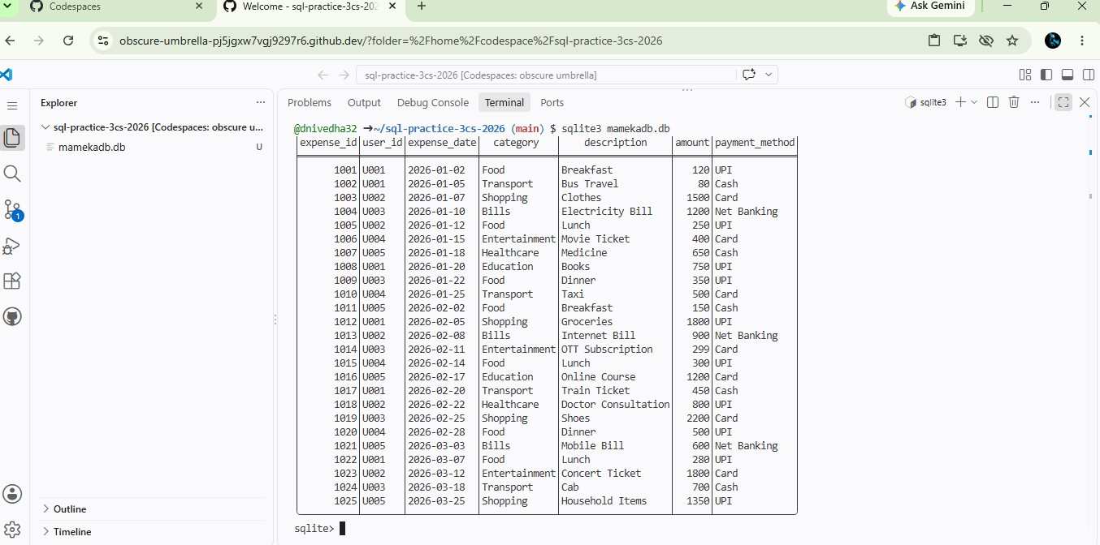

SQL Query 1: Display All Expenses

SELECT user_id, expense_date ,category, description,amount, payment_method
FROM personal_expenses ORDER BY expense_date;0
OUTPUT:

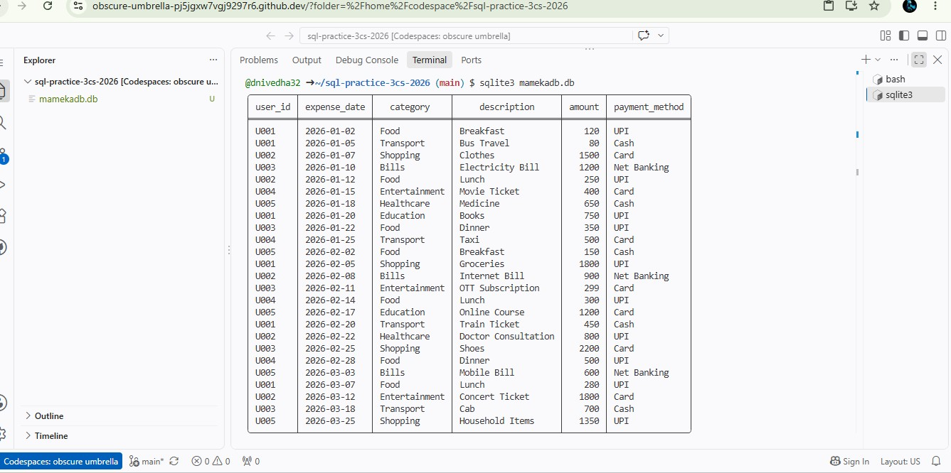

SQL Query 2: Calculate Total Monthly Expenses
SELECT strftime('%Y-%m', expense_date) AS expense_month,
SUM(amount) AS total_monthly_expenses
FROM personal_expenses
GROUP BY strftime('%Y-%m', expense_date)
ORDER BY expense_month; OUTPUT:
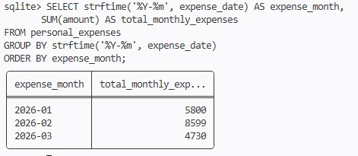
SQL Query 3: Calculate Total Spending for Each Expense Category
SELECT category,
SUM(amount) AS total_spending
FROM personal_expenses
GROUP BY category ORDER BY total_spending DESC;
OUTPUT:
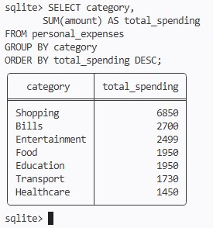
SQL Query 4: Identify the Five Highest Individual Expenses
SELECT expense_id,
user_id, expense_date, category, description, amount, payment_method
FROM personal_expenses
ORDER BY amount DESC
LIMIT 5;
OUTPUT:
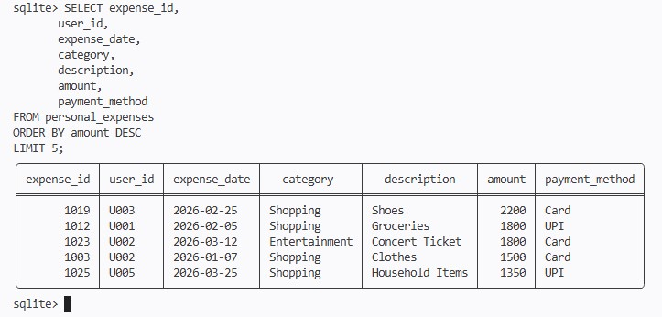

SQL Query 5: Transaction Count and Total Spending for Each Payment Method
SELECT payment_method,
COUNT(*) AS transaction_count,
SUM(amount) AS total_spending
FROM personal_expenses
GROUP BY payment_method ORDER BY total_spending DESC;
OUTPUT:
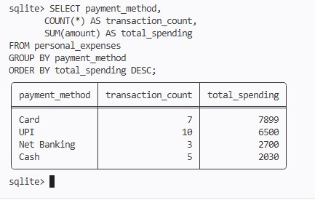
PL/SQL Tasks – SQLite Equivalent
Task 1: Add an Expense After Validation
INSERT INTO personal_expenses
(expense_id, user_id, expense_date, category,
description, amount, payment_method)
SELECT 1026,
'U001',
'2026-03-28',
'Food',
'Dinner',
450,
'UPI'
WHERE 450 > 0
AND 'Food' IN (
'Food',
'Transport',
'Bills',
'Shopping',
'Entertainment',
'Healthcare',
'Education'
);

OUTPUT:
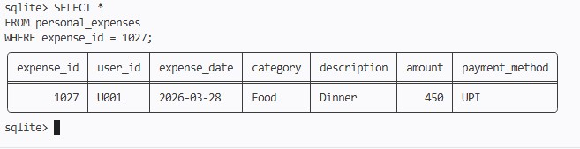

Task 2: Calculate Total Expenses of a Selected User for a Month
SELECT user_id,
SUM(amount) AS total_monthly_expense
FROM personal_expenses
WHERE user_id = 'U001'
AND strftime('%Y-%m', expense_date) = '2026-03'
GROUP BY user_id;

OUTPUT:

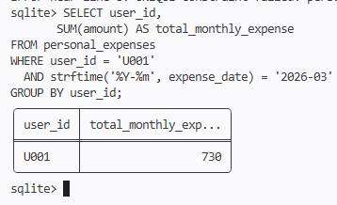
Task 3: Generate Monthly Budget-versus-Expense Report
SELECT
'U001' AS user_id,
'2026-03' AS expense_month,
1000 AS budget,
COALESCE(SUM(amount), 0) AS total_expense,
1000 - COALESCE(SUM(amount), 0) AS balance,
CASE
WHEN COALESCE(SUM(amount), 0) > 1000
THEN 'BUDGET EXCEEDED'
ELSE 'WITHIN BUDGET'
END AS status
FROM personal_expenses
WHERE user_id = 'U001'
AND strftime('%Y-%m', expense_date) = '2026-03';
OUTPUT:
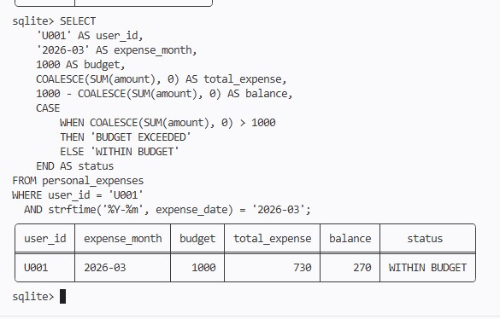
EXCEPTION HANDLING:
Test Case 1: Actual INSERT with validation
SELECT
CASE
WHEN 450 <= 0
THEN 'ERROR: Amount must be greater than zero'

WHEN 'Food' NOT IN (
'Food',
'Transport',
'Bills',
'Shopping',
'Entertainment',
'Healthcare',
'Education'
)
THEN 'ERROR: Invalid category'

WHEN EXISTS (
SELECT 1
FROM personal_expenses
WHERE expense_id = 1027
)
THEN 'ERROR: Expense ID already exists'

ELSE 'SUCCESS: Expense can be added'
END AS result;
OUTPUT:
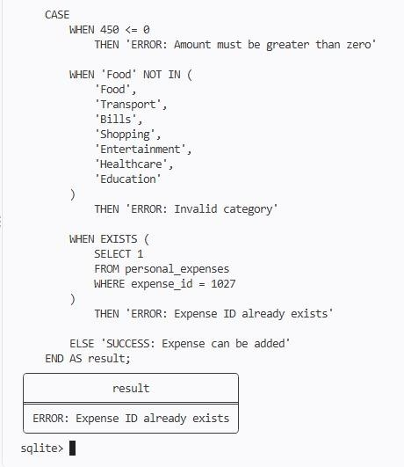
Test Case 2: Check result
SELECT
CASE
WHEN EXISTS (
SELECT 1
FROM personal_expenses
WHERE expense_id = 1027
)
THEN 'Expense inserted successfully'
ELSE 'Expense was not inserted'
END AS result;
OUTPUT:
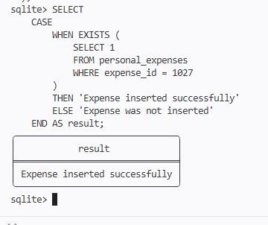

Dataset Insights
- The dataset contains 25 personal expense records.
- The expenses belong to categories such as Food, Transport, Shopping, Bills, Entertainment, Healthcare, and Education.
- The payment methods include UPI, Cash, Card, and Net Banking.
- Monthly expenses can be analyzed using the expense date and amount.
- The highest individual expenses can be identified using SQL.
- Category-wise aggregation helps analyze the total spending for each expense category.
- Payment-method-wise analysis helps identify the number of transactions and total spending.
Result
Thus, the Personal Finance and Expense Management system was successfully implemented using SQLite. The required PERSONAL_EXPENSES table was created, 25 expense records were inserted, SQL queries were executed successfully, monthly and category-wise expenses were analyzed, highest expenses were identified, and payment-method-wise spending was calculated. Validation and error handling were also implemented using SQLite queries.

